|  |  |  |
| --- | --- | --- |
| Test name | Test results | Comments |
| Does the HMD work? | Yes | - |
| Can Audio be heard through headphones? | Yes | - |
| Is the sound binaural? | Yes | The recording used for the experience was a binaural recording |
| Can the user see the environment? | Yes | Yes, however it doesn’t look too good when using a Mobile device as a HMD |
| Can the user see human models and their animations? | Yes | - |
| Is the animation in sync with audio? | Yes | Custom animations with Vizard are hard to achieve, and the creator of this experience, has very little knowledge of animating models in other software |
| Does SteamVR headset work with the application? | Yes | HTC Vive does work with the experience |
| Does Google Cardboard/ Mobile work as a HMD with the application? | Yes | It works by using the trinusVR third-party software that requires a server to run on the PC that the experience is being run on, as well as the TrinusVR app installed on the smartphone that will act as a HMD by emulating SteamVR hmd – HTC Vive. The server need to be set up to run on SteamVR settings |
| Is there a tutorial/user guide either implemented or in a separate file (word/text document)? | Yes | It is in this on the last page of this document |
| Is a menu/GUI implemented? | No | Bad time management caused this feature to not be implemented |
| Does the Audio and animations start at the start of the experience? | Yes |  |
| Can the experience be paused? | No | Same as menu/GUI |
| Does it support Oculus Rift? | No | Cannot seem to get it working |

**User Guide**

To run the experience, you will need Vizard installed on the PC you wish to use to run the experience.

It is required that SteamVR is installed on the computer to use the HTC Vive or Google Cardboard/smartphone as the HMD for the experience.

To run the experience on a smartphone/Google Cardboard, your smartphone must have the TrinusVR app installed, and your PC has to have the TrinusVR server installed with the following settings:

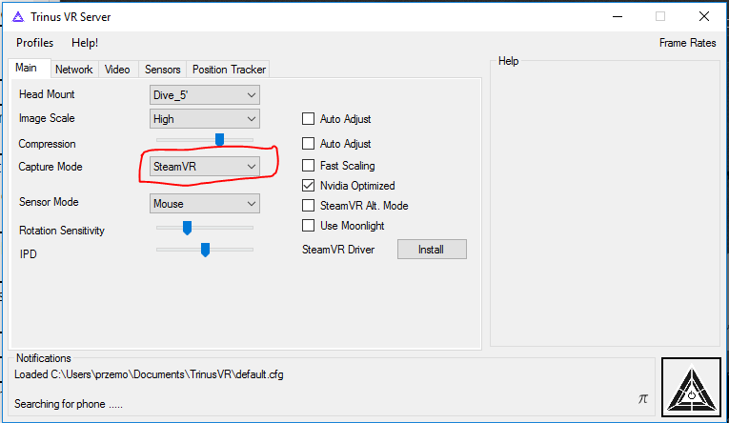

The headmount setting must match your smartphone screen size, in my case it was 5”. If you’re using GearVR for example, you choose one of the two GearVR options.

For the most immersive experience it is suggested that you set up your SteamVR for a seated mode, if you don’t want to change any settings, run the experience and stand in the position of the chair that is in the level. Then take off your headset, place a chair in the position you were standing in the real world, so when you sit down on it and run the experience you are facing the door/ TV screen.

Headphones/earphones are required for the experience, if you’re using a HTC Vive plug them into the HMD. If not, they must be plugged in directly to your computer.

Also for the experience to be immersive, you have face the doors during the experience, if you try to turn around the level will turn grey.

The application was tested and ran fine on the computer in open access area that is used with the HTC Vive, Eldon building.